**Peer-graded Assignment : Capstobe Project - The Battle of Neighborhoods (week1)**

**Introduction**

The Marina Bay Sands Hotel is located at Marina Bay in Singapore. The Marina Bay Sands Hotel is the most beautiful Hotel in Singapore. There are many tourists to stay here every years. So I think I should open Coffee shop near this hotel.

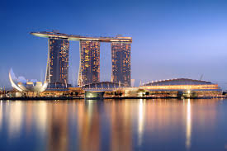

Figure.1: Marina Bay Sands Hotel in Singapore

**Business Problem:**

1. Find existing coffee shops around the Marina Bay Sands Hotel in radius 1.0 Km..
2. Find rating of exiting coffee shops for consideration to open my Coffee shop

**Data sources :** From www. Foursquare.com

1. Find Marina Bay Sands Hotel from map in [www.Fourssqusre](http://www.Fourssqusre) as below;

Address : 10 Bayfont Ave, 018986, Singapore

1. Run code will get location point of Marina Bay Sands Hotel as below;

Latitude : 1.283695

Lonitude : 103.8607722

1. Run code to find existing Coffee shops in radius 1.00 km from Marina Bay Sands Hotel. We will get list of 30 coffee shops as below;





1. Run code to show map of existing Coffee shops location around Marina bay Sands Hotel as shown below;



Figure 2: Location of 30 Coffee shops (blue points) around Marina Bay Sands Hotel ( Red point)

============End of Report for Week 1=================